**Lab Exercise - 2**

1. **How would you check a person is eligible to cast the vote.**

**Solution:**

**Eligible:**

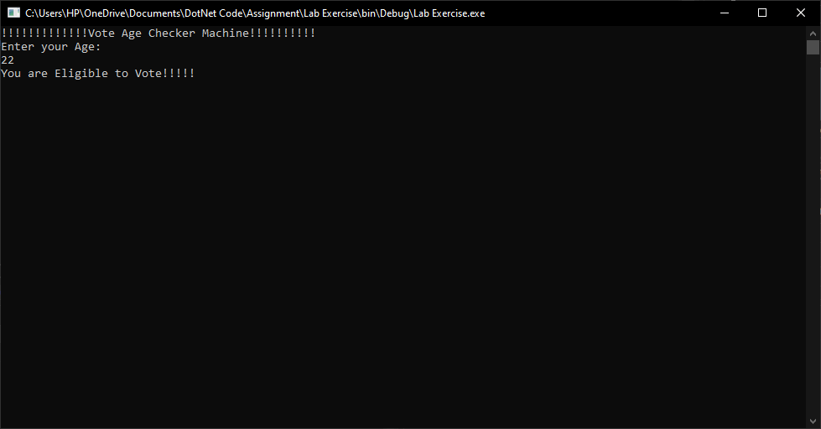

**Not Eligible:**

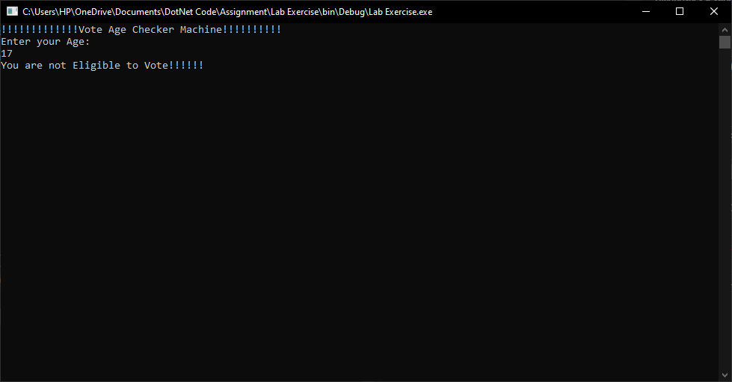

1. **Write a program to input a valid year and check whether entered year is leap year or not**

**Solution:**

**Leap Year**

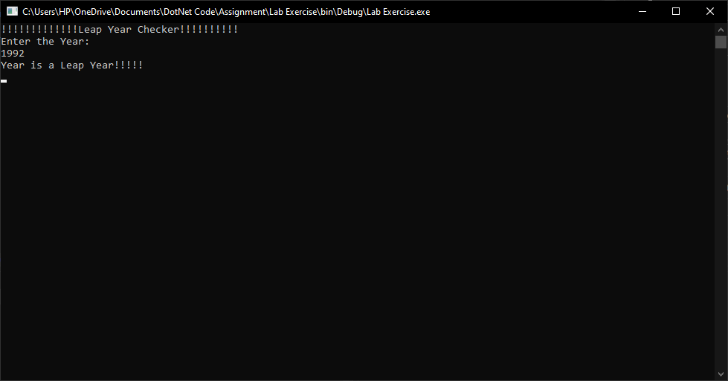

**Not a Leap Year:**

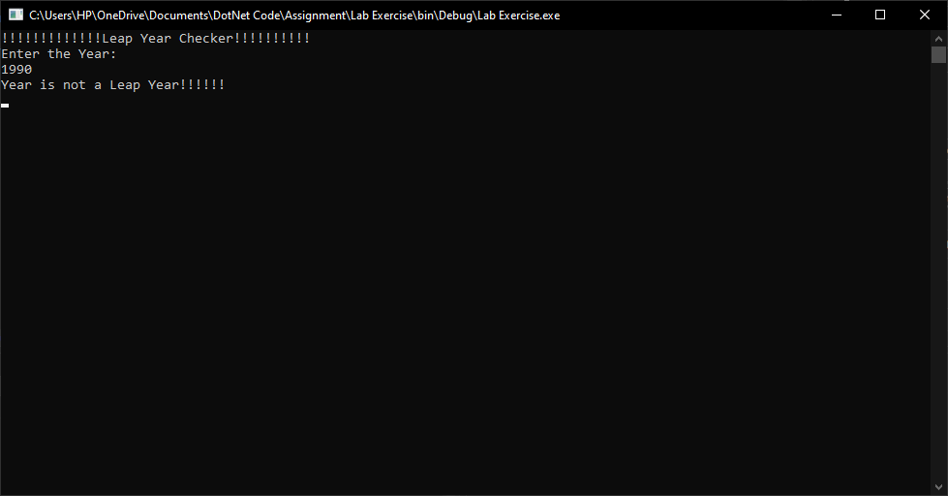

1. **Write a program to check the pin of ATM and allow a user to withdraw or deny**

**Solution:**

**Correct PIN**

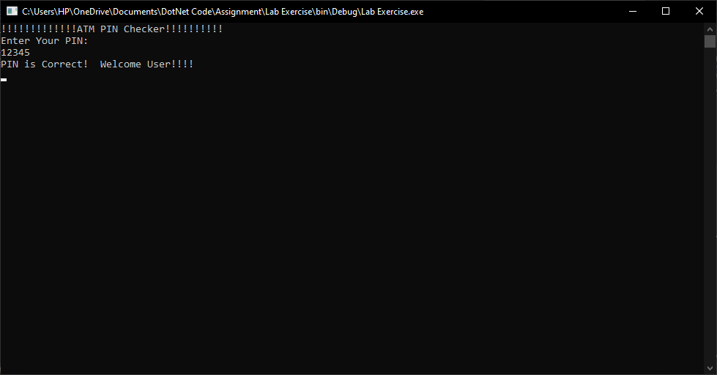

**Wrong PIN**

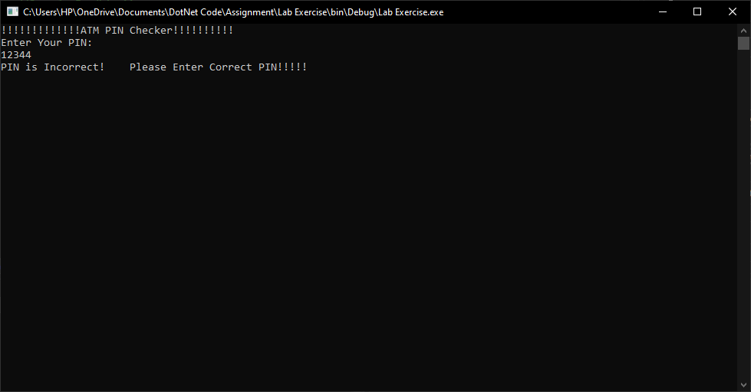

1. **The marks obtained by a student in 5 different Subjects are input through the keyboard. The Student gets a division as per the following rules.**
   1. **Percentage above or equal to 60 – First Division**

**Solution:**

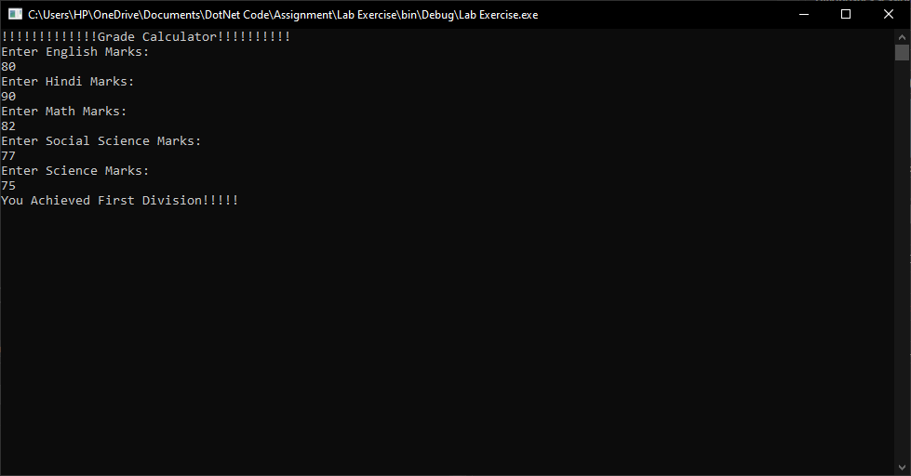

* 1. **Percentage between 50 and 59 – Second Division**

**Solution:**

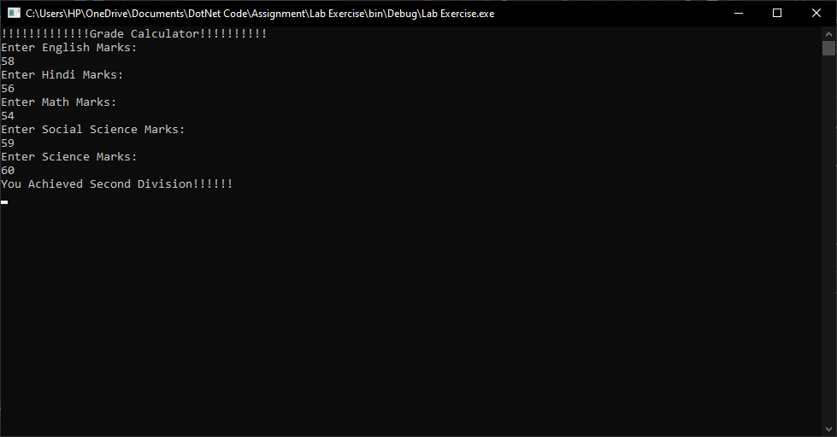

* 1. **Percentage between 40 and 49 – Third Division**

**Solution:**

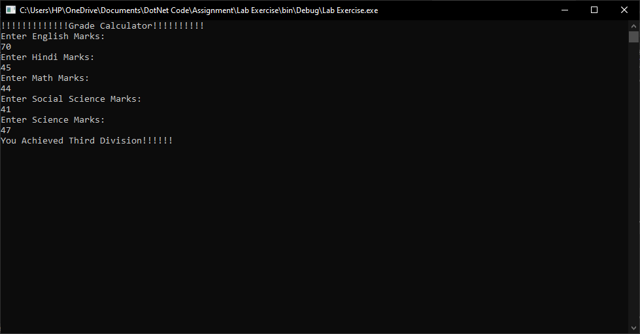

* 1. **Percentage less than 40 – Fail**

**Solution:**

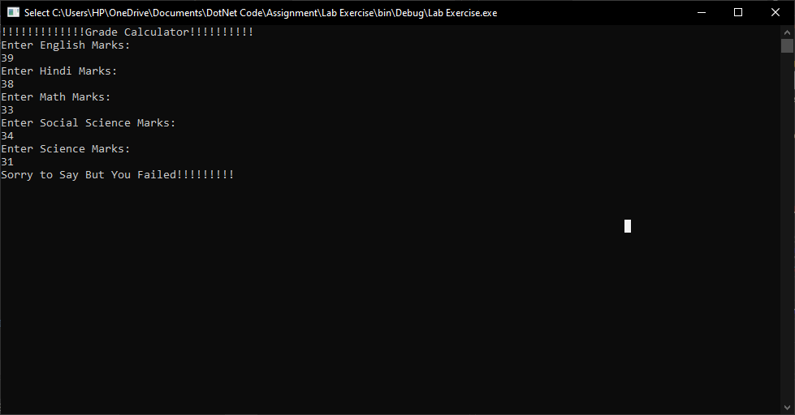

**Wrong Entry:**

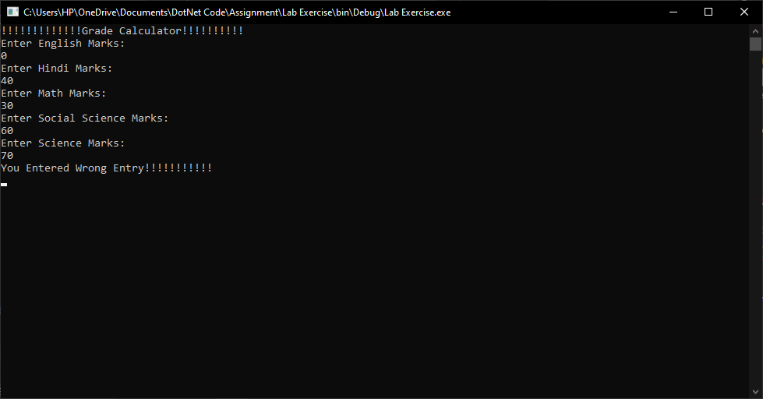

**5: Write a Program(WAP) to add all the odd numbers from 0 to 20.**

**Solution:**

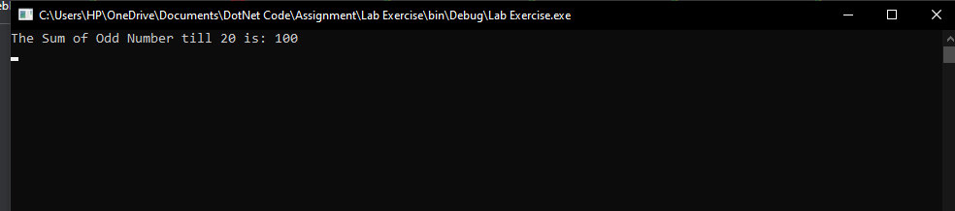

**6: WAP to display a Multiplication table of a number enter from keyboard.**

**Solution:**

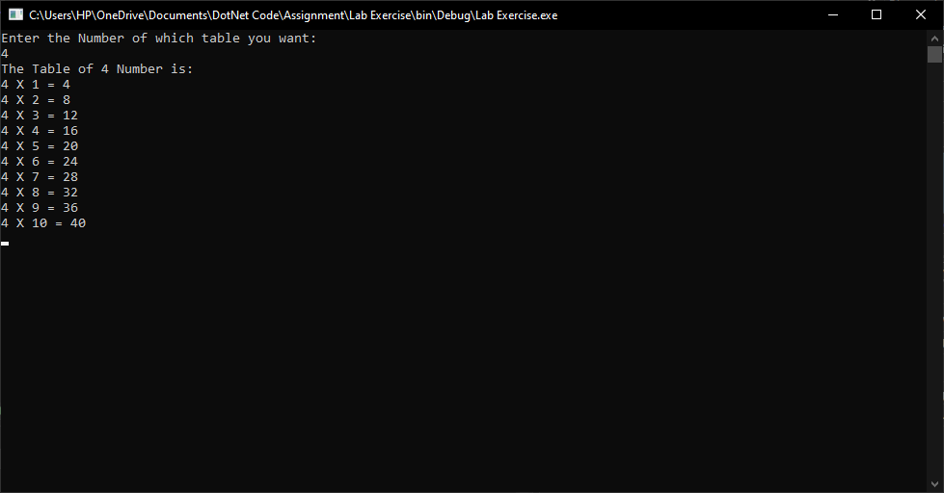

**7: Write a program to display the sum of square of the first ten even natural numbers**

**// (2*2+ 4*4 + 6*6 + 8*8 + 10*10 + 12*12 + 14 * 14 + 16 * 16 + 18*18 + 20*20)**

**Solution:**

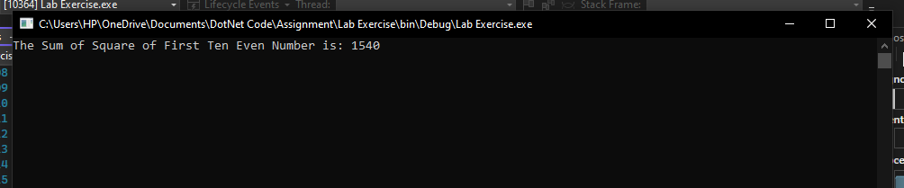

**8: Display the sum of: 1 + 1/4 + 1/7 + 1/10 + 1/13 + 1/16 + 1/19 + 1/22 + 1/25**

**Solution:**

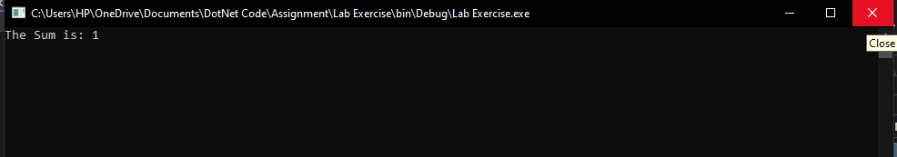

**9: Display ascii characters from 65 to 90**



**Solution:**

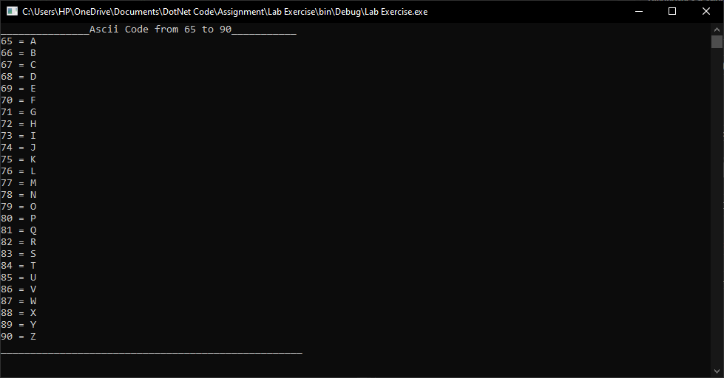

**10: Display ascii characters from 48 to 57.**



**Solution:**

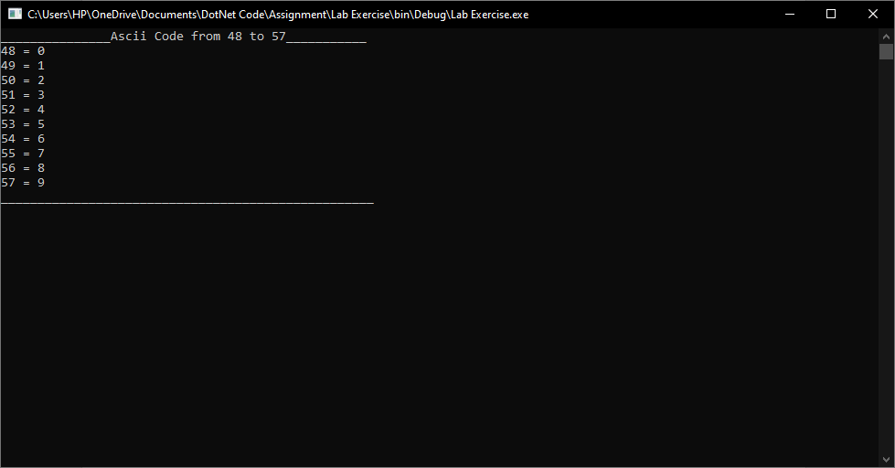

**11: Display the following output with the help of Ascii character.**



**Solution:**

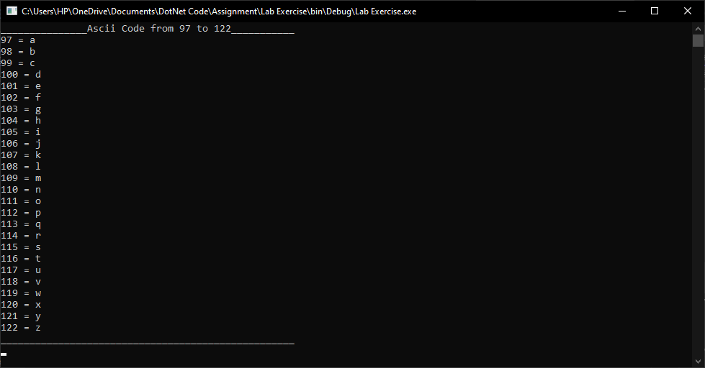

**Q. No 12 to 26: Write C# programs to print following patterns:**

1

2 1

3 2 1

4 3 2 1

**Solution:**

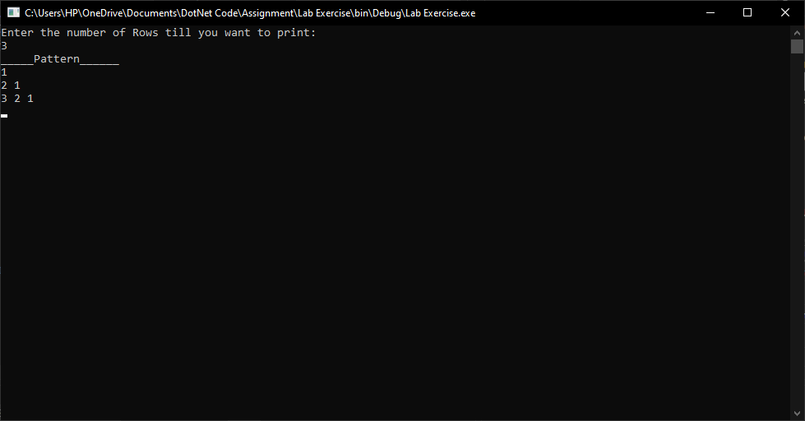

1

2 5

3 6 8

4 7 9 10

**Solution:**

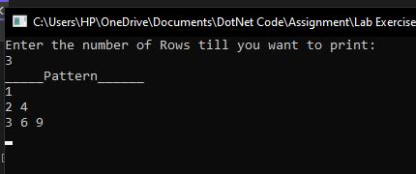

**Solution:**

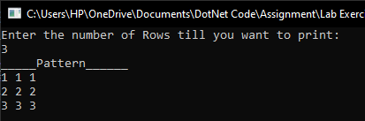

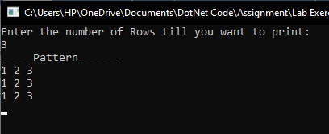

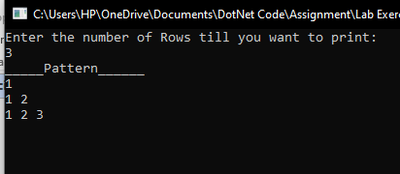

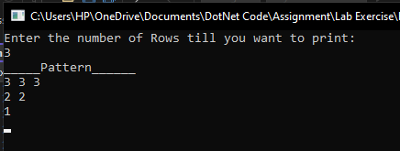

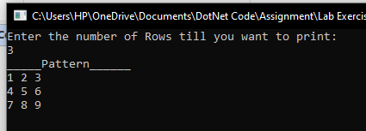

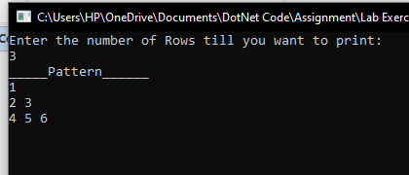

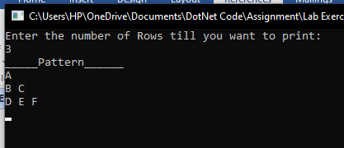

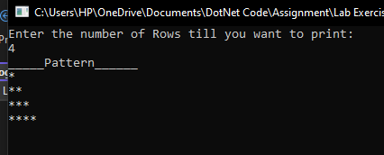

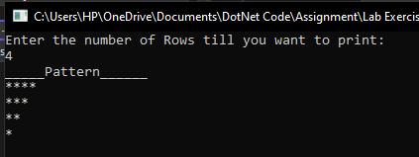

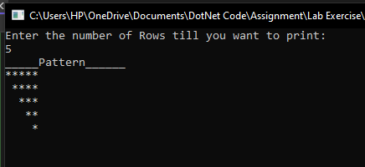

**Solution:**

